MARKET DATA ANALYSIS

TEAM NUMBER: 22
TEAM: Mini-Bloom
TEAM LEADER: Shekhar Singh

Problem Statement

To create a desktop application that provides a user-friendly interface for the users to access key market data views.

Requirements/Features

1. Graphically view changes in stock per ticker for different fixed-interval time frames .
2. User can customize the time interval to view the fluctuations for an individual stock in additional settings.
3. Graphically view changes in stock per basket.
4. Graphically view changes in stock per geographic location.
5. Drill down features to provide individual stock histories.
6. A compare button to allow the user to do a comparative analysis for multiple stocks.

Front-End

Create a user-friendly interface with a search box for retrieving stock quotes. One can search for the quotes using either the company name or ticker name. There’s also a search suggestion feature on the search box based on the partial names entered. Once the ticker is selected, we get a screen which displays the stock trends in a graphical format. The user can choose the time frame for viewing the stock trends. There is a compare button which allows the user to do a comparative analysis for multiple stocks. The prices of the chosen stocks will be plotted on the same graph using different colors for better comparison.

Back-End

When the user sends a HTTP request for retrieving an individual stocks information, the REST Server provides access to stock data resources and REST client accesses and presents the resources which is identified by URIs. The ApplicationRest.java file refers to the SessionBean file StockMarketBean.java which contains the functions which serves to different SQL queries. We have seven entity bean classes referring to the
seven different tables in the database. These entity classes have getters and setters functions corresponding to the columns of the different tables of our database.

Entity-Relationship Diagram

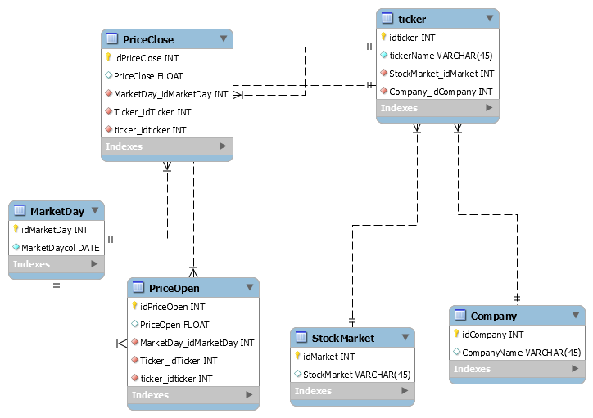

Class Diagram
